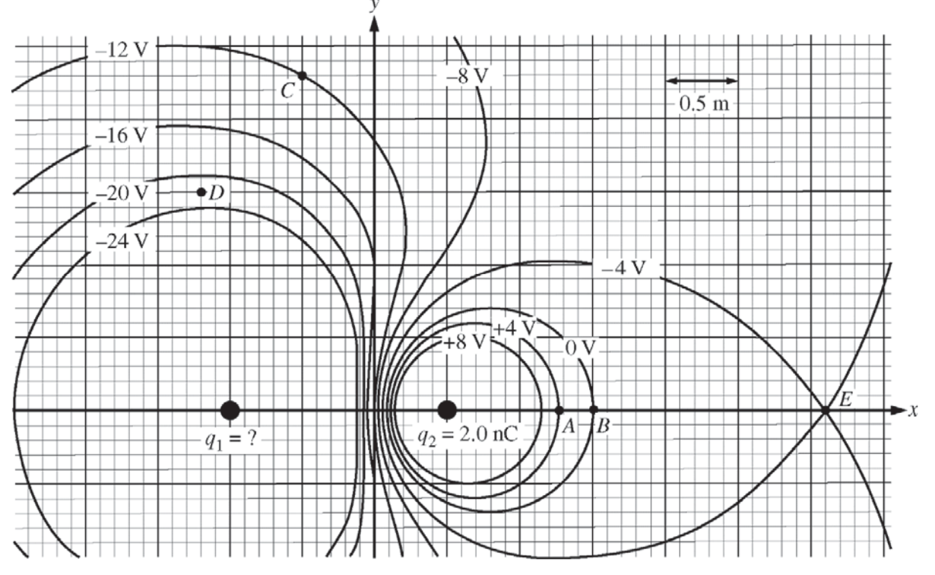
AP Exam Practice EM 2, 2016

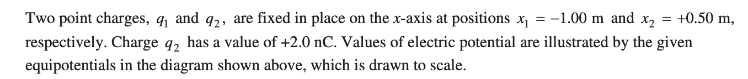

- Describe in words how you would calculate the value of q₁.

- Describe the direction of the electric at point C on the diagram. Explain your response.

- Describe how you would calculate the magnitude of the electric field at point D on the diagram.

- The equipotential labeled 0 V is the cross section of a nearly spherical surface. Which charge (s) contribute to the electric flux for this surface? Explain your response.

- A proton is placed at point A and then released from rest.

  - Is the work done on the proton by the electric field positive, negative, or zero as the proton moves from A to point E? Justify

  - How would you determine the speed of the proton when it reaches point E?

- An electron is released from rest at point B. Which of the following indicates the direction of the initial acceleration, if any, of the electron?

____ Up ____Down
____Left ____Right
____Into the page ____Out of the page
____The direction is undefined since the acceleration is zero.

Justify your answer

