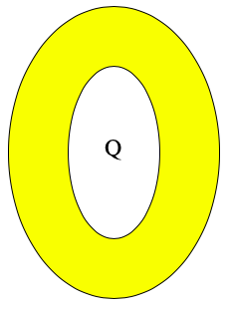
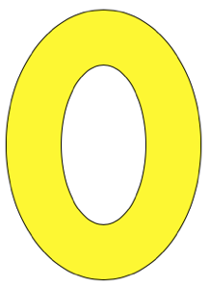
Off-the-Wall question #1: The cross-section of an electrically neutral, conducting, thick skinned, spherical shell that has been pulled into an oval shape sits in space (see first sketch). A shielded charge Q (that is, a charge that cannot affect its surroundings) is suspended at its geometric center (see second sketch).

- At a particular instant, the shielding around Q is removed. What, physically, is going on inside the conducting shell as that happenings (that is, during the first few instances after the shielding is removed).

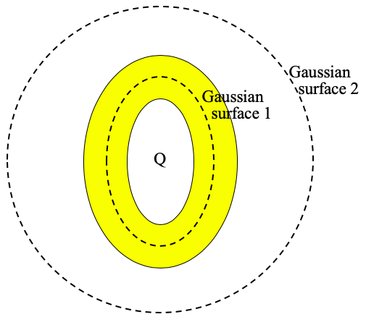
After some long period of time, two closed, imaginary, Gaussian surfaces are placed as shown in the final sketch.

- The magnitude of the amount of charge residing on the inner surface of the shell is:

___ zero ___ less than Q ___ equal to Q

___ greater than Q ___ cannot be determined due to geometry

Using what has been provided to you in the sketch (i.e., the Gaussian surfaces), justify your response.

- Will Gauss’s Law work with Gaussian Surface 2? Justify your response.

- Can you use Gaussian Surface 2 to determine the electric field function for the region outside the shell? Justify your response.

- Someone places 2Q’s worth of charge from an external source on the outside surface of the shell. After rearrange itself, the charge that is found on that outside surface will have distributed itself in what way? That is, will it:

___ distribute itself uniformly over the outside of the shell?

___ distribute itself with more charge per unit area close to the horizontal axis?

___ distribute itself with more charge per unit area close to the vertical axis.

Justify your response.

