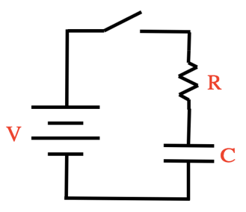
(15 min) A graph of a charging cap in an RC circuit is shown below. The switch was thrown at t = 0. The graph shows the charge drawn from the battery from t = 0 on. The positive values represent positive charge leaving the positive terminal. The dotted lines identify the slope of the graph at t = 0 and the line the graph reaches asymptotically after a long time.
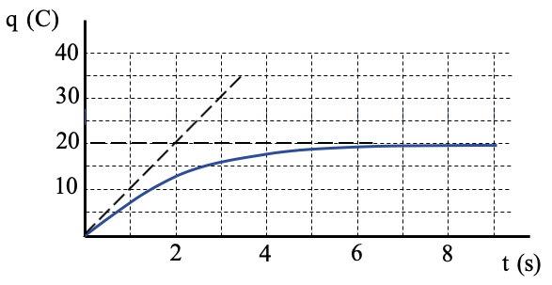

- Suggest values for V in volts, R in ohms and C in farads that could have generated the graph. Explain your reasoning.

- You are asked to create a second graph with twice the initial slope but with the same horizontal asymptote. You have access to one battery of voltage V, one additional resistor R, one capacitor of capacitance C and several additional wires. How could one or more of those elements might be used to affect that task. Justify your response.

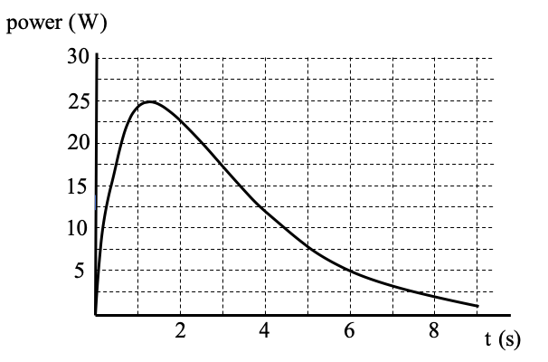
- A student creates a graph of the power delivered to the cap as a function of time. Explain why the graph starts at zero, reaches a maximum and then asymptotically approaches zero again.

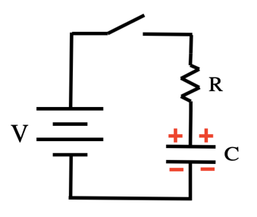
- In a different experiment, a student charges the cap to a voltage that is twice that of the battery with the polarities as shown. Describe how the graph of the charge vs. time at the top of the page would appear now if the switch was closed at t = 0. Be sure to address the initial slope and final asymptote of the graph. Justify your response.

